**W3-S2** PRACTICE

*MANIPULATE BASIC WIDGETS*

## *Learning objectives*

* Start from an **empty Flutter project**
* **Hot Reload**
* Use Flutter **doctor**, **update**, create, run
* Use Flutter **Documentation**
* Manipulate **Scaffold**, Text, TextStyle, Radius
* Manipulate Colors palettes
* Manipulate **Container**, BoxDecoration, Center, EdgeInsets, Column
* Create a **Custom stateless** widget

 *No AI tools allowed to solve this practice*

## *How to submit?*

* **Push** your final codeon **your GitHub repository**
* Then **attach the GitHub path** to the MS Team assignment and **turn it in**

## *Are you lost?*

*Read the following documentation to be ready for this practice:*

<https://api.flutter.dev/flutter/material/Scaffold-class.html>

<https://docs.flutter.dev/ui/widgets/text>

<https://api.flutter.dev/flutter/widgets/Center-class.html>

<https://api.flutter.dev/flutter/painting/EdgeInsets-class.html>

<https://api.flutter.dev/flutter/widgets/Column-class.html>

<https://api.flutter.dev/flutter/widgets/Container-class.html>

<https://api.flutter.dev/flutter/painting/BoxDecoration-class.html>

# BEFORE THIS PRACTICE

#### Where are you in your Tools skills?

Before the practice we expect you to **be able to run the default Flutter Project** using an android Device

**If you cannot perform it, ask your group teammate to support you before the practice day!**

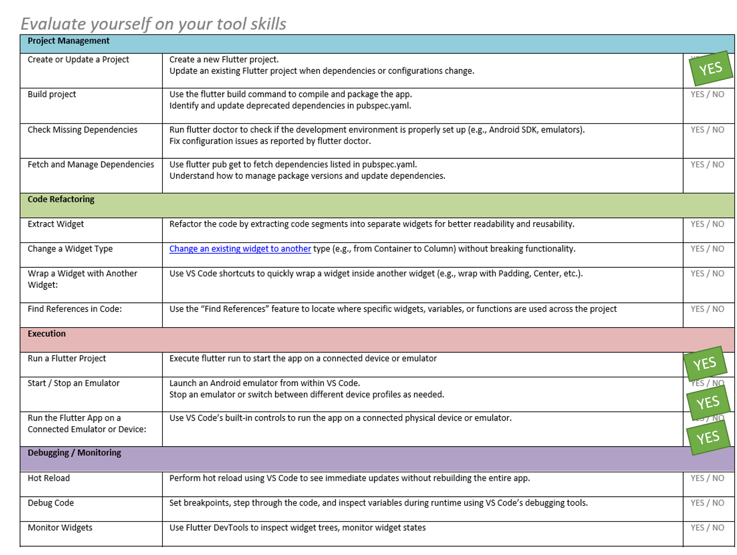

# EX 1 – Scaffold, Text

In this exercise, you will be working with the following widgets

* **Scaffold:** Provides a basic structure for UI, like app bar, drawer, etc.
* **Center**: Aligns a child widget to the center
* **Text**: Displays text.

And the following classes

* **TextStyle**: Styles text appearance.

You need to produce the following mockup and widget structure:

 You are free to customize it!

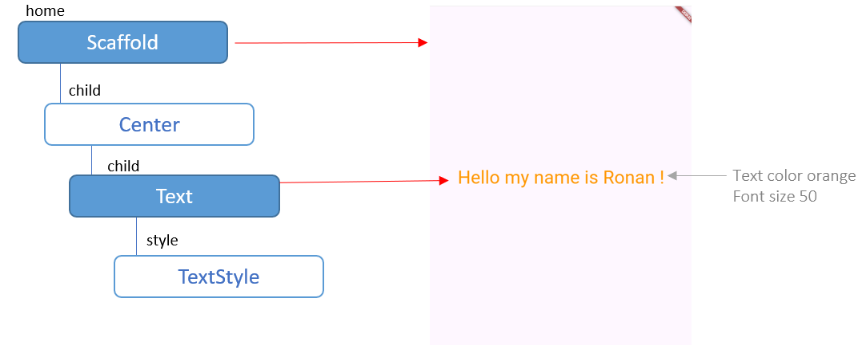

To start

Open W3-S2/EX-1/main.dart

void main() {

  runApp(

    const MaterialApp( ),

  );

}

# EX 2 – Container, Insets, BoxDecoration

In this exercise, you will be working with the following widgets

* **Container**: A customizable box for layout and styling.
* **Text**: Displays text.
* **Center**: Aligns a child widget to the center

And the following classes

* **EdgeInsets**: Sets padding or margin.
* **BoxDecoration**: Styles a container's background, border, etc.
* **BorderRadius**: Rounds container corners.
* **TextStyle**: Styles text appearance.

You need to produce the following mockup and widget structure:

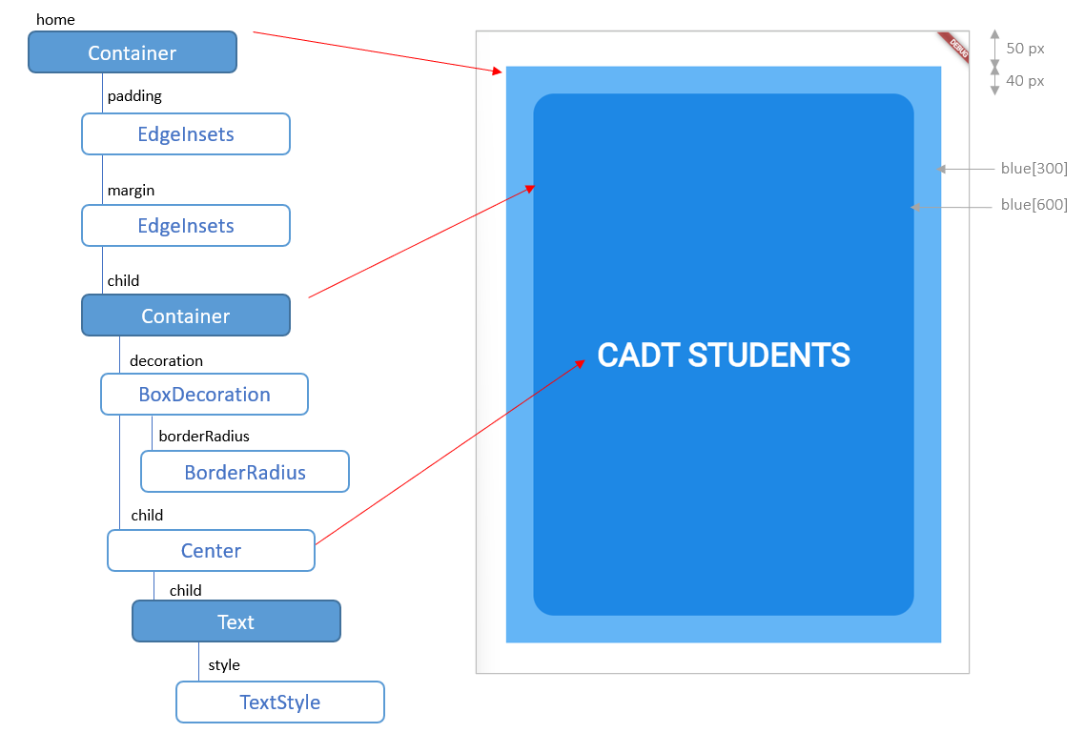

 We recommend you to follow **the bellow steps** to be able to understand each widget in details.

However, you are free to choose your favorite workflow!

To start

Open W3-S2/EX-2/main.dart

void main() {

  runApp(MaterialApp(

    home: Container( ),

  ));

}

|  |  |  |
| --- | --- | --- |
| STEP 1 |  | Just a blue container for the home…  MaterialApp  home: Container |
| STEP 2 |  | Add an inner container and some padding margins and box decoration  MaterialApp  home: Container  margin: EdgeInsets  padding: EdgeInsets  child: Container  decoration: BoxDecoration |
| STEP 3 |  | Add the Text, centered, and style it.  MaterialApp  home: Container  margin: EdgeInsets  padding: EdgeInsets  child: Container  decoration: BoxDecoration  child: Center  child: Text  style TextStyle |

 In this exercise, we haven’t used the Scaffold widget: **Why**? What is the **purpose of this widget**?

# EX 3 – Column Gradient,

In this exercise, you will be working with the following widgets

* **Container**: A customizable box for layout and styling.
* **Column** Arranges widgets vertically in a column.

And he following classes

* **EdgeInsets**: Sets padding or margin.
* **BoxDecoration**: Styles a container's background, border, etc.

You need to produce the following mockup and widget structure:

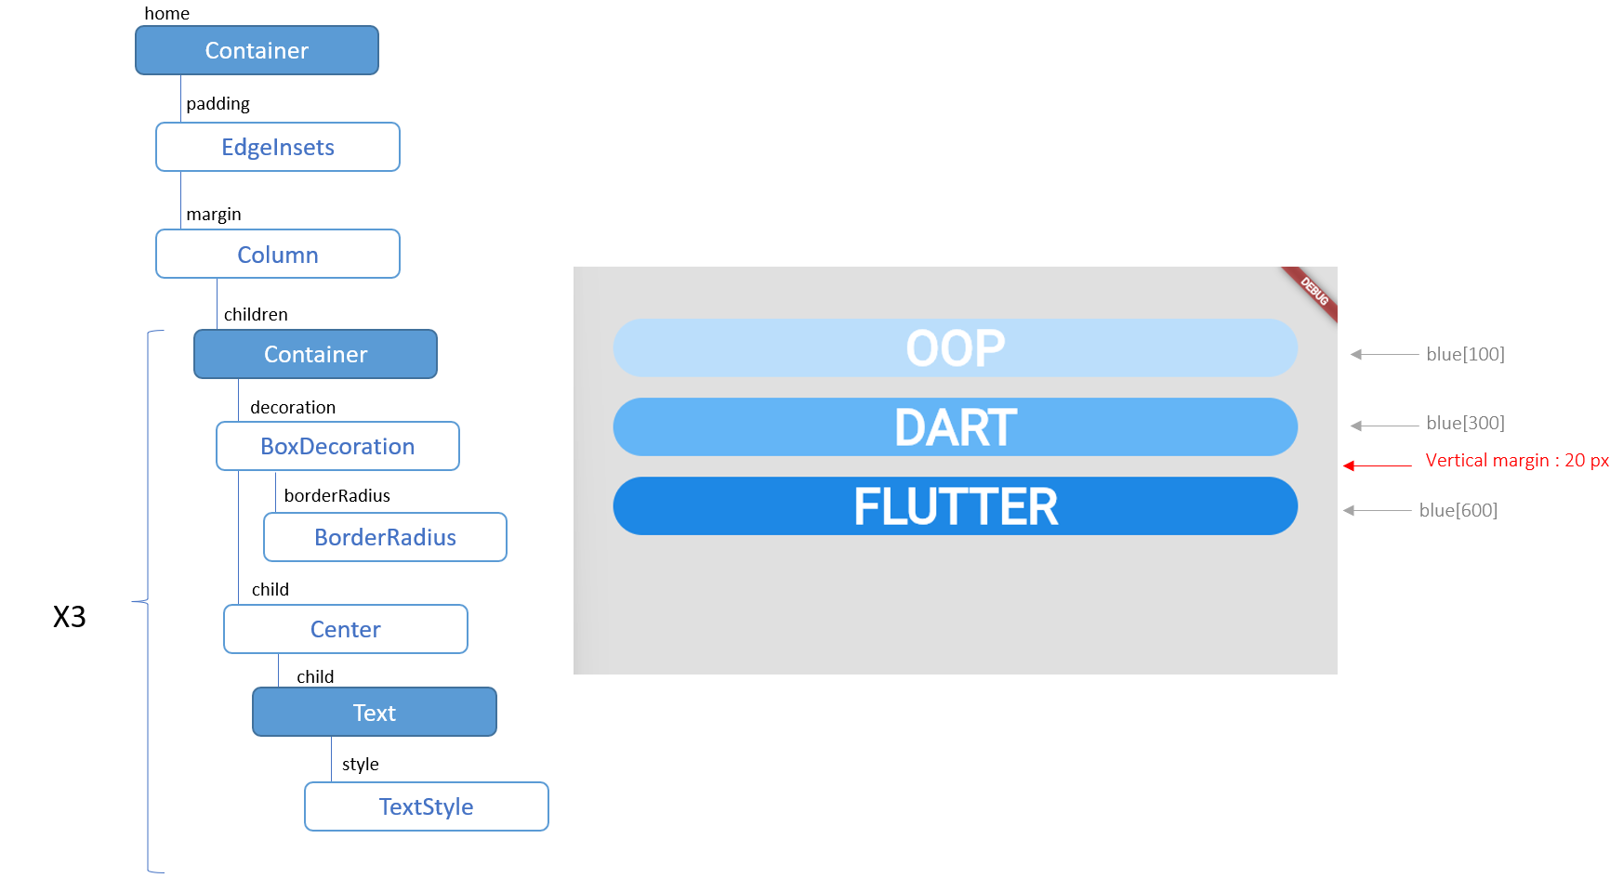

#### BONUS

In the last item, add a [linear gradient](https://api.flutter.dev/flutter/painting/LinearGradient-class.html) as specified bellow

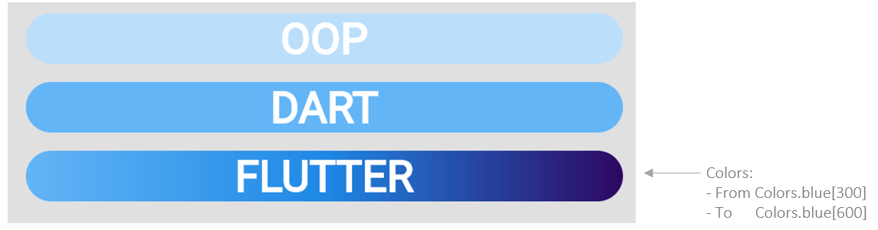

# EX 4 – Extract widget to a Stateless Widget

Startin from previous exercise, your You need to extract the repetitive card design into a custom Stateless Widget called CustomCard.

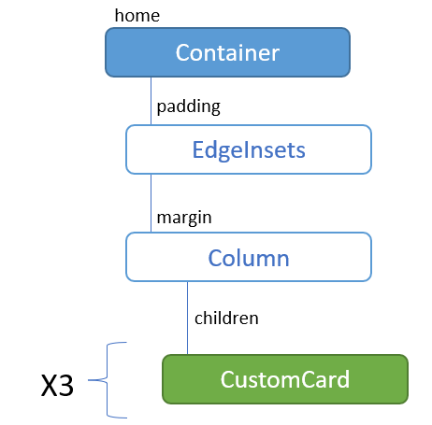

This custom widget will take 2 parameters:

|  |  |  |  |
| --- | --- | --- | --- |
| Parameter name | Type | Is optional? | Default value |
| Text | String | no | No |
| Color | Color | yes | Blue |

As example the previous code will be refactored as follow:

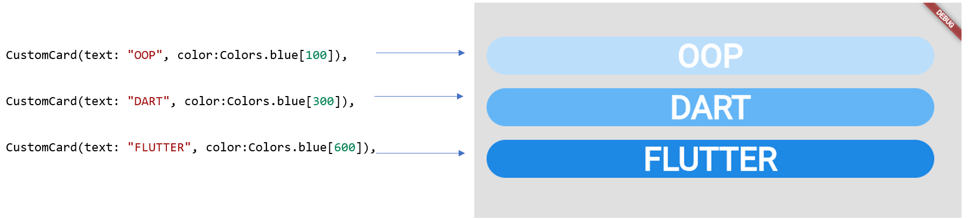

**Q1 –** Starting from previous exercise, extract the Container into a Stateless widget (CustomCard)

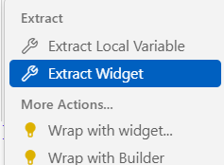

*VSCode can help you to extract widget!*

**Q2–** Add widget constructor parameters

**Q3 –** Update the main() to call this CustomCard widget

#### BONUS

If you were able to manage **linear gradient**, add another constructor parameter to display the card with gradient colors.